Wano’s Web
Exploring Character Networks in One Piece

Christopher Santiago
College of Engineering and Computer Science
University of Central Florida
Orlando, Florida 32826–5010
Email: ch295541@ucf.edu

Abstract—The exploration of network science, particularly social network analysis, offers powerful insights into the interplay of characters within a narrative. This study applies various network analysis techniques to the character interactions in the Wano Arc of the One Piece anime. The network represents relationships and interactions among characters, providing a nuanced understanding of their centrality and influence.
In this analysis, centrality measures such as degree centrality, closeness centrality, betweenness centrality, and eigenvector centrality are employed to gauge the significance of individual characters. The presence and absence of the central character, Luffy, are examined to unravel shifts in narrative dynamics.
Methodologies for the analysis are detailed, encompassing the extraction of character interactions and the computation of centrality metrics. The results, presented in the Analysis section, illuminate key findings. Notably, Luffy emerges as a central character, significantly shaping the narrative. However, removing Luffy redistributes narrative influence, highlighting the critical roles of other characters, including Mononosuke, Kin'emon, and Zoro.
The narrative structure proves to be resilient, showcasing a dynamic ensemble where various characters contribute meaningfully to the storyline. Insights derived from the centrality measures underscore the evolving nature of the narrative, challenging the traditional notion of Luffy as the sole main character.
This analysis contributes to the broader understanding of narrative structures in anime and storytelling, emphasizing the collaborative and distributed nature of character influence within complex story arcs.

Introduction (Heading 1)
In the expansive world of One Piece, narratives are woven intricately through the interactions and relationships of its diverse cast of characters. The Wano Arc stands as a testament to the series' complexity, offering a rich tapestry of storylines, alliances, and conflicts. In our exploration, we delve into the heart of this narrative through the lens of network analysis, aiming to unravel the dynamics that govern the interactions among characters.

Network science provides a unique vantage point, allowing us to visualize and quantify the relationships that shape the story. The characters, like nodes in a vast network, contribute to the overarching narrative, each playing a distinct role in the unfolding saga. Our analysis employs advanced methodologies, drawing inspiration from social network analysis, to dissect the structure of the Wano Arc character network.
As we venture into this analysis, our objectives are twofold. Firstly, we seek to identify the central characters whose influence reverberates throughout the network, defining the narrative's core. Secondly, we explore the narrative's resilience by investigating how its structure adapts when a central character, in this case, Luffy, is temporarily removed. These insights promise a deeper understanding of how characters collectively shape the narrative landscape.
Join us on this journey through the corridors of Wano, where characters, alliances, and the essence of storytelling converge. Through the application of network analysis, we aim to extract patterns, unveil complexities, and offer a fresh perspective on the collaborative nature of character influence in the vibrant world of One Piece.

History

Punk Hazard Arc
The road to Wano was set in motion during the Punk Hazard Arc. Trafalgar Law, a prominent character and a member of the Worst Generation, proposed an alliance with the Straw Hat Pirates, led by Monkey D. Luffy, to take down one of the Four Emperors of the Sea, Kaido. This alliance planted the seeds for the epic clash that would unfold in Wano.

Dressrosa Arc
The alliance gained momentum in the Dressrosa Arc, where Luffy, Law, and their allies, including the Samurai of Wano, faced formidable challenges. The Dressrosa Arc solidified the bond between the Straw Hat Pirates and the Wano Samurai, setting the stage for their united front against the tyrannical rule of Kaido.

Zou Arc
The journey continued with the Zou Arc, where the Straw Hat Pirates reached the elephantine island of Zou. Here, they discovered the devastating impact of Kaido's actions on the Mink Tribe, further fueling their resolve to confront the Emperor of the Sea.

Whole Cake Island Arc
As the crew advanced, the Whole Cake Island Arc unfolded, showcasing Luffy's confrontation with Big Mom, another of the Four Emperors. This arc not only added layers to the overarching narrative but also revealed the complexities of the power dynamics at play in the world of One Piece.

Reverie Arc
The Reverie Arc provided glimpses into the global consequences of the unfolding events, emphasizing the interconnectedness of the world, and setting the stage for a colossal clash between powerful forces.

The Wano Arc holds profound significance in the One Piece narrative. It serves as a battleground where the Straw Hat Pirates, their allies, and the Samurai of Wano unite against Kaido, a symbol of tyranny. Beyond the physical conflict, Wano represents a turning point in the series, where alliances forged in the crucible of previous arcs converge to reshape the world order.

The themes of freedom, justice, and the indomitable spirit of the characters converge in Wano, making it a pivotal chapter in the epic tale of One Piece.

HYPOTHESIS AND DATA COLLECTION

Data Collection
The foundation of this project rests on a dual approach to data collection, combining personal expertise with the collaboration of dedicated fans. Having been an avid viewer of the One Piece anime since its inception in 1997, my deep familiarity with the series provided a solid groundwork for analysis.

However, recognizing the expansive nature of the Wano Arc, which spanned from 2018 to 2022, and the intricate web of character interactions, I embraced a complementary strategy. To ensure a comprehensive dataset, I turned to a crowdsourced wiki, harnessing the collective knowledge and meticulous documentation of fellow enthusiasts. This collaborative effort became instrumental in filling gaps and capturing nuances in character dynamics that might have faded from memory over the arc's multi-year duration. [1]

An additional aspect of our data collection strategy warrants mention, specifically pertaining to the initial refinement of our network. The Wano Arc introduces a staggering cast, boasting over 350 named characters. Recognizing the need for visual clarity and analytical efficiency, we made a deliberate decision to focus our attention on the top 50 characters most frequently featured in the manga panels [2].

Hypothesis 1
In our pursuit of understanding the intricate character dynamics within the Wano Arc, we formulated two fundamental questions. Firstly, our aim is to identify central characters, those pivotal to the narrative's structure. Through an assessment of the network, we anticipate encountering the following characters associated with distinct groups:

Pirate
- Luffy
- Zoro
- Sanji
- Nami
- Chopper
- Brook
- Franky
- Kaido
- Big Mom

Ninja
- Kin’emon
- Mononosuke

Mink
- Inuarashi
- Nekomamushi
- Carrot

Hypothesis 2

Our second objective involves selecting a central character, where we expect Luffy to wield the greatest network influence. By foreseeing the significant impact of Luffy’s absence, we anticipate notable alterations in connections and the prominence of characters with high centrality measures.

graphs and measurements
In Figure 1 below, we present the graph featuring the top 50 characters most frequently observed in manga panels. The edges between nodes signify interactions between characters within the anime. This undirected graph maintains a uniform edge weight of 1, disregarding any variations. Our analysis, conducted with the aid of the Gephi software, will delve into five centrality measures. This exploration aims to identify and establish the primary characters of the Wano Arc, aligning with the first hypothesis. Subsequently, our analytical journey will lead us to draw conclusive insights regarding the second hypothesis.
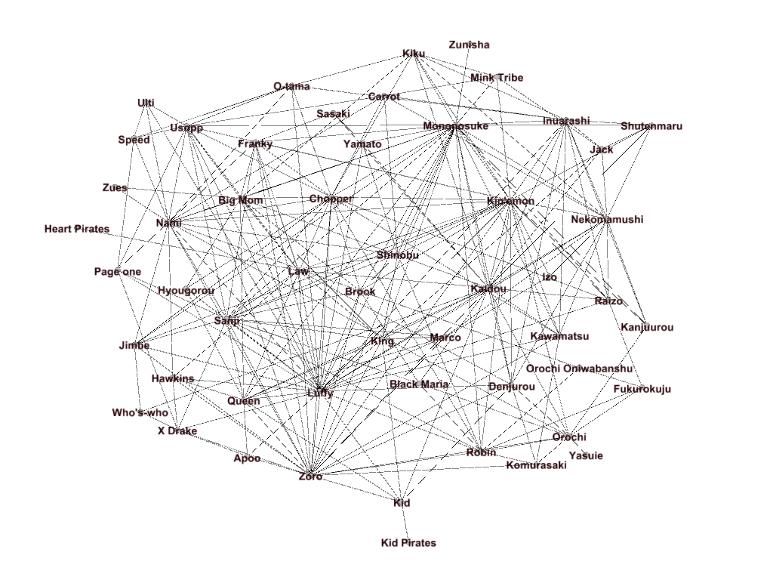 Fig 1. This graph shows the nodes of our network for context of our analysis.

Degree Centrality
In our analysis of the One-Piece character network, we've identified 'central characters.' But what does that mean? In the context of network analysis, central characters are those who play pivotal roles in connecting with the most other characters. They serve as key influencers, bridges, or even anchors within the network, and their interactions can significantly shape the narrative.
Therefore, we begin with degree centrality. Degree centrality provides insights into the level of connectivity of a node, highlighting nodes that serve as pivotal connectors within the network. Nodes with high degree centrality are often considered influential or central in facilitating information flow or interactions within the network. Below, Table I display the top 10-degree centrality ranking for our graph.

- TOP 10 DEGREE CENTRALITY

Rank | Top 10 Degree Centrality Nodes
Rank | Name of Node | Degree
1 | Luffy | 33
2 | Kin’emon | 31
3 | Mononosuke | 30
4 | Zoro | 25
5 | Kaidou | 24
6 | Nami | 20
7 | Sanji | 19
8 | Chopper | 19
9 | Nekomamushi | 18
10 | Inuarashi | 17

For an undirected graph, the degree centrality of a node i is calculated as the total number of edges incident to i divided by the total number of nodes in the graph. We described this formula more formally below.

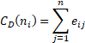 (1)

Examining the top 10-degree centrality members confirms that all of them align with our initial hypothesis, hypothesis 1.

Closeness Centrality
Closeness centrality assesses the proximity of a node to all others in the network. A node is deemed significant in closeness centrality if it is relatively close to all other nodes. In our network context, closeness centrality gauges how swiftly a character can connect with all others. Characters exhibiting high closeness centrality demonstrate efficient access and interactions with their peers. As depicted in Table 2 below, our top-10 rankings remain consistent.
Closeness is based on the inverse of the geodesic distance of each node to every other node in the network, as shown here:
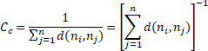 (2)

- TOP 10 CLOSENNESS CENTRALITY
Rank | Top 10 Closeness Centrality Nodes
Rank | Name of Node | Closeness
1 | Luffy | 0.7027
2 | Kin’emon | 0.65
3 | Mononosuke | 0.65
4 | Zoro | 0.65
5 | Kaidou | 0.6190
6 | Nami | 0.5977
7 | Sanji | 0.5977
8 | Chopper | 0.5843
9 | Nekomamushi | 0.5474
10 | Inuarashi | 0.5474

As depicted in Table 2 above, our top-10 rankings remain consistent. The fact that the top 10 rankings remain unchanged for both measures indicates a consistent pattern in the network. The characters identified as important by degree

centrality are also identified as central in terms of closeness.

Betweenness Centrality

Betweenness centrality quantifies the frequency with which a node lies on the shortest path between two other nodes in the network. This centrality metric gauges the significance of a node in facilitating the flow of information and connections across the network. The calculation for betweenness centrality is expressed by the formula:

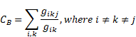 (3)

Betweenness centrality serves as a tool to pinpoint characters functioning as pivotal bridges or intermediaries between distinct groups or storylines within the network. These characters play a crucial role in upholding connections throughout the network. In Table 3 below, it's noteworthy that four new characters have entered our top-10 list. The inclusion of these characters is logical – Law and Kid hold leadership roles as captains of their respective crews, Orochi leads a distinct faction within our group of villains, and Robin engages in interactions across all groups.

- TOP 10 BETWEENESS CENTRALITY

Rank | Top 10 Betweenness Centrality Nodes
Rank | Name of Node | Betweenness
1 | Luffy | 211.36
2 | Kaidou | 142.85
3 | Mononosuke | 141.08
4 | Kin’emon | 133.56
5 | Zoro | 107.02
6 | Nami | 101.67
7 | Orochi | 78.47
8 | Law | 58.93
9 | Kid | 51.33
10 | Robin | 48.30

Page Rank
The PageRank algorithm, developed by Google, is a variant of eigenvector centrality and was employed to derive these values. PageRank determines the importance of a node relative to other nodes in the network. In our network's context, characters with high PageRank are frequently central to the main storyline, with their actions and decisions carrying significant narrative weight. As shown in the results of this metric, many familiar characters reappear, with one noteworthy addition: Big Mom, who plays a pivotal role in the overarching narrative.

- TOP 10 PAGERANK

Rank | Top 10 PageRank
Rank | Name of Node | PageRank
1 | Luffy | 0.0487
2 | Mononosuke | 0.0424
3 | Zoro | 0.0383
4 | Kin’emon | 0.0382
5 | Kaidou | 0.0354
6 | Nami | 0.0335
7 | Sanji | 0.0304
8 | Chopper | 0.0297
9 | Nekomamushi | 0.0237
10 | Big Mom | 0.0236

Eigenvector Centrality
Eigenvector centrality assesses a node's significance in a network, considering the importance of its neighbors. Building upon the concept of degree centrality, it gauges a character's importance by evaluating their connections to other influential characters. High eigenvector centrality suggests that a character is connected to other highly influential characters. The basic equation for eigenvector centrality is as follows:

(4)

Where x is the eigenvector and λ is the scalar eigenvalue.

Thus, the Table 5 below provides us with connectedness to influential characters.

- TOP 10 EIGENVECTOR CENTRALITY

Rank | Top 10 Eigenvector Centrality
Rank | Name of Node | Eigenvector
1 | Kin’emon | 1.0
2 | Luffy | 0.947
3 | Mononosuke | 0.927
4 | Zoro | 0.767
5 | Kaidou | 0.739
6 | Nekomamushi | 0.606
7 | Chopper | 0.603
8 | Inuarashi | 0.598
9 | Sanji | 0.593
10 | Nami | 0.559

Defining the Central Character
Central characters, as we've previously discussed, are the pillars of our narrative. They are the characters who have the most connections, influence, and interactions within the One Piece network. They serve as the cornerstones, driving the storyline, and connecting various character groups and story arcs. In addressing the central inquiry regarding the primary character, our methodology involved determining the main character based on the most favorable average ranking across the five centrality measures. Characters appearing in at least one top 10 were considered potential main characters. As illustrated in Figure 2 below, our findings duly designate Luffy as the principal central character.

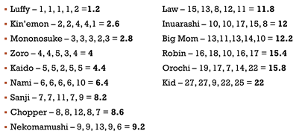

Fig. 2 Average Centrality Ranking Across the 5 Measures

Egonetwork Removal
Now, consider this: What happens when we alter this network by removing one of these central characters? How does it affect the overall narrative? To answer these questions, we'll conduct an analysis to explore the consequences of 'removing' a central character, symbolically, from the network.
For our analysis, we've chosen to focus on Luffy, the central character and captain of the Straw Hat Pirates. Luffy's presence in the network is immense, as he connects with allies, rivals, and various factions. Removing him, even in theory, allows us to understand the profound influence he has on the story and the network dynamics.

Network Analysis After Removal
Figures 3 and 4, below, provides us insights into our centrality measures with and without Luffy’s inclusion.
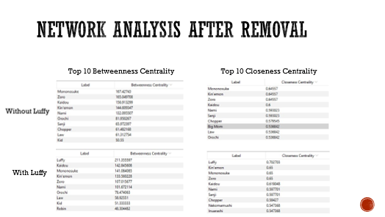

Fig. 3 Top 10 Betweenness and Closeness Centralities with and without Luffy

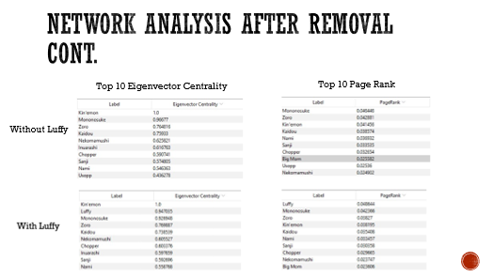

Fig. 4 Top 10 Eigenvector Centrality and PageRank with and with Luffy

Removing Luffy redistributes centrality and elevates characters like Mononosuke and Kin'emon, highlighting their importance in the network. Characters who maintain their positions in the top 10 of centrality measures demonstrate that their roles are pivotal to the storyline. Their interactions, influence, and connections continue to be essential for the network's structure.

Conclusion and final remarks
Upon conducting a comprehensive examination, encompassing our initial analysis and the subsequent exploration following the removal of our central character, Luffy, we now turn our attention to reflection. While hypothesis 1 largely aligned with expectations, featuring some nuances for characters like Carrot, Brook, and Franky, it is crucial to note that our analysis concentrated on the top 10 measures. Expanding our scope to the top 12 or 15 may reveal a more comprehensive alignment with our hypothesis.
In contrast, our second hypothesis appears to face challenges, at least on the surface. As we delve deeper into our findings, we can elucidate the factors contributing to these results.

Diverse Network Structure: One possible conclusion is that the One Piece storyline and the Wano arc, in particular, have a diverse and robust network structure. This diversity means that there are multiple central characters and key players who collectively shape the narrative. Even without Luffy, other central characters, such as Kin'emon and Inuarashi, maintain strong connections and influence within the network.

Narrative Resilience: The narrative of the Wano arc is structured in a way that it can adapt to changes in character centrality. This resilience suggests that the story is not solely dependent on one character but rather on the interactions and relationships of multiple characters. The absence of Luffy may not disrupt the overall narrative flow, indicating a well-balanced storyline.

Luffy's Evolving Role: It could also signify that Luffy's role in the network has evolved over the course of the Wano arc. While he remains a central character, other characters and groups have stepped up to share the narrative spotlight. Luffy's centrality may have shifted as the arc progresses, reflecting changes in his alliances and interactions

Network Complexity: The One Piece world is known for its complexity, with numerous factions, alliances, and interconnected storylines. If Luffy's exclusion has limited impact, it may demonstrate the intricacy of the network, where the narrative is influenced by multiple factors, not solely reliant on one character.
One final note to further analysis. Perhaps it is worth considering weights in the relationship between nodes.

References
- (n.d.). Wano Country Arc. One Piece Wiki. https://onepiece.fandom.com/wiki/Wano_Country_Arc
- Mic, C. (n.d.). Reddit. Dive into anything. https://www.reddit.com/r/OnePiece/comments/wvkjan/a_comprehensive_breakdown_of_wanos_panels

